- USER STORY: VIEW STUDENTS LIST
Card | - As a teacher  - I want to view the list of students in my class  - So that I know who I am teaching.
Summary | Allows teachers to view the list of students enrolled in their class, including student information and learning status.
In-Scope: | - Teachers can select a class to view the student list.  - The system displays a list of students in the selected class.  - Teachers can search students by name, student ID, or phone number.  - Teachers can navigate between pages of the student list.
Out of scope | - Teachers cannot edit student information.  - Teachers cannot add new students.  - Teachers cannot delete students from the system.  - Teachers cannot view students from other classes they do not teach.
Trigger | Student opens the Student List page after login
Pre-condition | - Teacher must be logged in.  - Teacher must be assigned to at least one class.  - Student data must exist in the system.
Business rule and error message | - Teachers can only view students from classes they are assigned to.  - Students are displayed in a table format.  - Teachers can search students using name, student ID, or phone number.  - Student status can be displayed (e.g., Studying, On hold).  - No students found -> shows "Không có học sinh nào trong lớp."
Screen design | 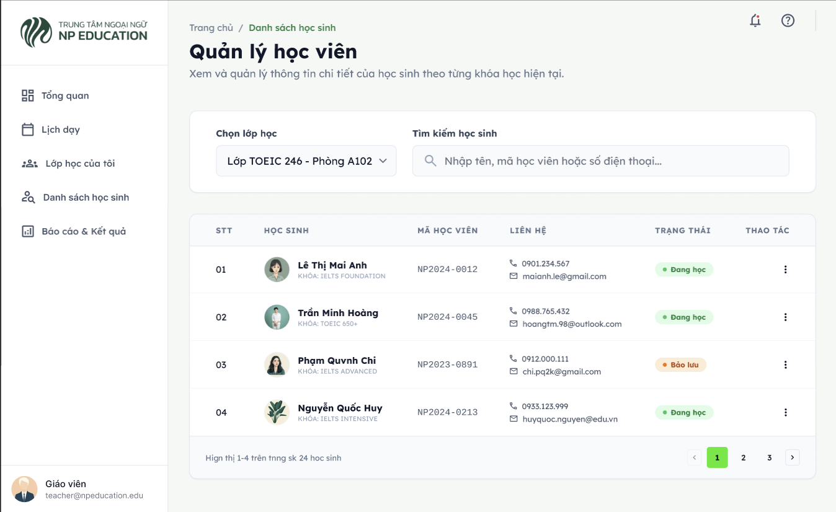
Screen description | Name Description Type Min Max Maxlength Required  Class selection Select a class to view students dropdown - - - yes  Search Search student by name, ID, or phone text - - 100 no  Student name Name of the student text 1 100 100 yes  Student ID Unique ID of the student text 1 20 20 yes  Contact Student text - - 100 yes  Status Student learning status label - - - yes
Acceptance Criteria | - The student list includes the following information:  - Student name  - Student ID  - Contact information (phone, email)  - Course name  - Learning status
- USER STORY: VIEW ASSIGNMENT DEADLINE
Card | - As a student,  - I want to view assignment deadlines  - So that I can submit assignments on time.
Summary | Allows students to view all assignment deadlines of their enrolled courses.
In-Scope: | - Student can view list of all assignments with their exact due dates and times  - Display submission status (Submitted / Not submitted / Late)  - Sort assignments by due date  - Filtering assignments by status or course.  - View detailed assignment description
Out of scope | - Creating or editing assignments.
Trigger | Student opens the "Assignment Deadline" page after login.
Pre-condition | - Student must be logged in  - Student must be enrolled in at least one course  - Assignment data must exist in the system
Business rule and error message | - The list must dynamically update the "Status" based on the current system time  - If the user has no assignments assigned to them, the system shows: “Bạn không có bài tập nào sắp đến hạn.”  - Overdue assignments must be visually distinct (e.g., red text and warning icon) to alert the user.
Screen design
Screen description | Name Description Type Min Max Maxlength Required  Bộ lọc Filter assignments by status (Tất cả, Chưa nộp, Đã nộp, Quá hạn) varchar(255) - - - no  Tên bài tậo Name of assignment varchar(255) 1 200 200 yes  Tên môn học Name of course varchar(255) 1 100 100 yes  Hạn nộp Deadline date and time datetime - - - yes  Trạng thái Submission status label - - - yes  Xem chi tiết Redirect to assignment detail page button - - - no
Acceptance Criteria | - Student can open the Assignment Deadline page after login.  - System displays list of assignments sorted by nearest due date.  - Each assignment shows title, course name, due date, and status.  - Student can filter assignments by course.  - Student can search assignments by title.  - Overdue assignments are clearly highlighted.  - System displays the empty state message if no assignment exists.  - Student can click “View Detail” to see assignment information.
- USER STORY: UPLOAD LEARNING MATERIALS
Card | - As a teacher,  - I want to upload learning materials  - So that students can access learning resources.
Summary | Allows teachers to upload learning materials (PDF, video, slides, documents) for their assigned courses.
In-Scope: | - Uploading physical files (PDF, DOCX, PPTX, MP4).  - Adding material titles.  - Assigning the material to a specific course and lesson/module.
Out of scope | - Bulk upload multiple files at once  - Preview file before upload  - File size auto compression  - Integration with external storage (Google Drive, Dropbox)  - Tracking whether a student has completely read/watched the material.
Trigger | Teacher clicks the "Upload Material" button from the Learning Materials page.
Pre-condition | - Teacher must be logged in.  - Teacher must be assigned to at least one class.  - Student data must exist in the system.
Business rule and error message | - Teacher can only upload materials to courses they are assigned to.  - File size must not exceed 100MB.  - Only allowed file formats can be uploaded.  - Title and File cannot be empty. If empty, show: “Vui lòng nhập tên tài liệu và chọn tệp tải lên.”  - If file format invalid → show:  “Định dạng tệp không được hỗ trợ. Vui lòng chọn tệp PDF, Word, PowerPoint hoặc Video.”  - If file exceeds size limit → show:  “Dung lượng tệp vượt quá giới hạn cho phép (Tối đa 100MB).”  - If upload successful → show:  “Tài liệu tải lên thành công”
Screen design
Screen description | Name Description Type Min Max Maxlength Required  Môn học Select course dropdown - - - yes  Tên tài liệu Name of material varchar(255) 1 200 200 yes  Mô tả Material description varchar(255) - - - no  Chọn file Select file from device file - 100MB - yes  Tải lên Submit material to system button - - - yes  Hủy Hủy tải lên button - - - no
Acceptance Criteria | - Teacher can open Upload Learning Materials page after login.  - Teacher can select a course.  - Teacher can upload a supported file type.  - System validates file size and format.  - System prevents upload if required fields are empty.  - After successful upload, material appears in course materials list.  - Error messages are displayed clearly if validation fails.  - Once created, the material automatically appears in the "Learning material" page for all students enrolled in that specific course.
- USER STORY: CREATE ASSIGNMENT
Card | - As a teacher,  - I want to create assignments  - So that students can practice what they learned.
Summary | Allows teachers to create assignments for their assigned courses.
In-Scope: | - Setting assignment title and detailed instructions.  - Setting a start date and a deadline (due date).  - Attaching reference materials or template files for the assignment.
Out of scope | - Setting the maximum score for the assignment.  - System sends notification to enrolled students after assignment creation  - Automatic grading
Trigger | Teacher clicks the “Create Assignment” button from the Assignment Management page.
Pre-condition | - Teacher must be logged in.  - Teacher must be assigned to at least one class.  - Course must exist in the system
Business rule and error message | - Teacher can only create assignments for courses they are assigned to.  - Assignment title cannot be empty.  - Due date must be in the future and cannot be earlier than current date/time. If invalid, show: "Thời gian bắt đầu không hợp lệ."  - Attachment file size must not exceed 100MB. If exceeded, show: “Dung lượng tệp đính kèm vượt quá 100MB.”  - Title, Course/Lesson, Start Date, and Deadline cannot be empty. If empty, show: “Vui lòng điền đầy đủ các trường thông tin bắt buộc.”  - If creation successful → show:  “Tạo bài tập thành công.”
Screen design
Screen description | Name Description Type Min Max Maxlength Required  Course Select course dropdown - - - yes  Assignment Title Name of assignment varchar(255) 1 200 200 yes  Description Assignment details varchar(255) 1 200 200 yes  Due Date Deadline date date - - - yes  Due Time Deadline time time - - - yes  Attachment Upload reference file file - - - yes  Create Button Submit assignment button - - - yes  Cancel Cancel creation button - - - no
Acceptance Criteria | - Teacher can open Create Assignment page after login.  - System validates required fields.  - System prevents assignment creation with past due date.  - If file attachments are added, they are successfully uploaded and linked to the assignment description.  - Upon successful creation, the system displays a success message and redirects the user to the assignment list.  - Once created, the assignment automatically appears in the "View Assignment Deadline" list for all students enrolled in that specific course.
- USER STORY: ASSIGN TEACHERS TO CLASSES
Card | - As an admin,  - I want to assign teachers to classes  - So that each class has an instructor.
Summary | Allows administrators to assign teachers to specific classes in the system.
In-Scope: | - Admin can view list of classes  - Admin can view list of teachers  - Admin can assign one teacher to one class  - Admin can view current teacher assigned to each class  - Checking for scheduling conflicts for the selected teacher.  - System updates teaching schedule automatically after assignment
Out of scope | - Assign multiple teachers to one class (team teaching)  - Automatic teacher-class matching
Trigger | Admin clicks the “Assign Teacher” button from Class Management page.
Pre-condition | - Admin must be logged in  - Teacher account must exist and be active  - Class must exist in the system
Business rule and error message | - One class can only have one assigned teacher.  - A teacher can be assigned to multiple classes.  - Admin cannot assign inactive teachers.  - If no teacher is selected → show:  “Vui lòng chọn một giáo viên chính cho lớp học”  - If class already has a teacher → show confirmation message before reassigning.  - If assignment successful → show:  “Giáo viên này đã được phân công vào lớp học.”  - The system must check the teacher's current schedule. If the teacher is already assigned to another class that takes place at the exact same time, show: “Giáo viên này đã có lịch dạy trùng vào thời gian của lớp học. Vui lòng chọn giáo viên khác.”
Screen design
Screen description | Name Description Type Min Max Maxlength Required  Chọn lớp Select a class dropdown - - - yes  Giáo viên Select teacher dropdown - - - yes  Phân công Confirm assignment button - - - yes
Acceptance Criteria | - Admin can open Assign Teacher page after login.  - Admin can select a class.  - Admin can select a teacher.  - System validates teacher and class exist.  - System prevents assignment without selecting teacher.  - After successful assignment:  - Teacher appears as assigned in class details.  - Teacher’s teaching schedule is updated.
- USER STORY: ENROLL STUDENT IN CLASS
Card | - As an admin,  - I want to enroll students in classes  - So that they can attend the appropriate courses.
Summary | Allows administrators to assign students to specific classes in the system
In-Scope: | - Admin can view list of students  - Admin can view list of classes  - Selecting a class and adding single or multiple students to it.  - Admin can view list of students currently enrolled in a class  - System updates student schedule automatically after enrollment  - Searching for existing students by Name, Email, or Student ID.
Out of scope | - Automatic class placement based on level  - Payment processing
Trigger | Admin clicks the “Enroll Student” button from Class Management page.
Pre-condition | - Admin must be logged in  - Student account must exist and be active  - Class must exist in the system  - Class must not exceed maximum capacity
Business rule and error message | - A student can enroll in multiple classes.  - A class can contain multiple students.  - Student cannot be enrolled twice in the same class. If the student is already on the roster, show: “Học viên này đã có trong danh sách lớp.”  - Enrollment is blocked if class reaches maximum capacity. If adding the selected student(s) exceeds this limit, show: “Lớp học đã đạt số lượng tối đa. Không thể thêm học viên.”  - If enrollment successful → show:  “Đã thêm học viên vào lớp thành công.”
Screen design
Screen description | Name Description Type Min Max Maxlength Required  Class selection Select a class to view students dropdown - - - yes  Student Select student select - - - yes  Search Search student by name/email varchar(255) 1 100 100 no  Enroll Button Confirm enrollment button - - - yes
Acceptance Criteria | - Admin can open Enroll Student page after login.  - Admin can select a class.  - When the Admin searches for a student, the system returns accurate results based on the active student database.  - Admin can select one or multiple students.  - The system actively blocks the enrollment and displays the appropriate error if it violates capacity limits or duplicate rules.  - System prevents enrollment when class is full.  - After successful enrollment:  - Student appears in class student list.  - Student’s weekly schedule is updated.  - Student can access class materials and assignments.
- USER STORY: SUBMIT HOMEWORK
Card | - As a student,  - I want to submit homework through the system  - So that I can send my work to the teacher easily.
Summary | Allows students to upload and submit homework files before the assignment deadline.
In-Scope: | - Upload and submit homework before deadline  - View submission status (Submitted / Late / Not submitted)  - System records submission date and time  - Student can resubmit homework before deadline  - Student can view submitted file
Out of scope | - Automatic grading  - Plagiarism detection  - Group submission  - File editing within system
Trigger | Student clicks the “Submit Homework” button from the Assignment Detail page.
Pre-condition | - Student must be logged in  - Student must be enrolled in the course  - Assignment must exist  - Assignment deadline must not be expired (for on-time submission)
Business rule and error message | - Students can only submit assignments of enrolled courses.  - Submission must be before deadline for on-time status.  - If submission after deadline → status automatically marked as “Nộp muộn”.  - File size must not exceed 100MB.  - Only allowed file types (PDF, DOC, DOCX) can be uploaded.  - If no file selected → show:  “Vui lòng tải lên tệp.”  - If file format invalid → show:  “Tệp tải lên không đúng định dạng.”  - If file exceeds size limit → show:  “Dung lượng tệp vượt quá giới hạn cho phép (Tối đa 100MB).”  - If submission successful → show:  “Nộp bài tập thành công.”
Screen design
Screen description | Name Description Type Min Max Maxlength Required  Tên bài tập Name of assignment label - - - yes  Hạn nộp Deadline of assignment datetime - - - yes  Tải tệp lên Select file from device file - 100MB - yes  Nộp bài Submit homework button - - - yes  Hủy Cancel submission button - - - no  Trạng thái nộp bài Shows current status label - - - yes
Acceptance Criteria | - System displays confirmation after successful submission  - Student can open assignment detail page.  - Student can upload homework file.  - System validates file size and format.  - System records submission date and time.  - The teacher can immediately see the student's submitted files and timestamp in their dashboard.

